Pt. I Art History (5pts. Each. 40 total)
Identify the Title with the Work of Art
1. The Milkmaid…………………………………………………………………________
2. Praying Hands………………………………………………………………..________
3. Life-Boat and Manby Apparatus……………….…………………...________
4. The Oath of Horatii………………………………………………………...________
5. The School of Athens………………………………………………………________
6. David with the Head of Goliath.……………………………………..________
7. Apples and a Pomegranate…………………………………….………________
8. The Blue Dancers…………………………………………………………..________
Pt. II Identify the fact with the Work of Art (5pts. Each. 40 total)
9. N. Renaissance, Appropriated the Use of the Printing Press…_________
10. Dutch Golden Age, used the camera obscura…………………….._________
11. Neoclassic, Official Artist of the French Revolution. …………..._________
12. Abolitionists artist from England………………………………………...._________
13. Impressionist, Sought to capture the “impression of the moment”_________
14. Renaissance painting of Humanist philosophers ……………………_________
15. Baroque painting of the weak triumph over the strong……....…__________
16. Realist Wanted “no prettiness but Truth”……………………………..___________
Pt. III Appropriation 5 pts. Each (20 total)
17. In your own words, define Appropriation.
_____________________________________________________________________________________
18. What was appropriated to make Lady with a Green Stripe?
_____________________________________________________________________________________
19. What was appropriated and the inspiration for La Ghirlandata?
____________________________________________________________________________________
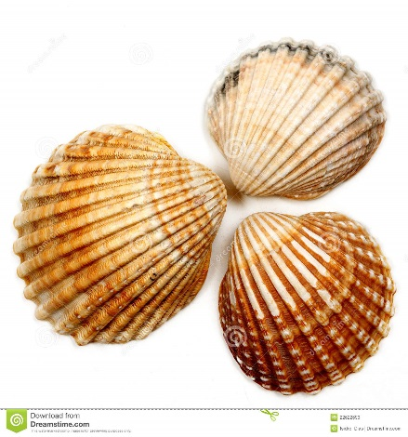
20. Demonstrate appropriation of the following image into a new work of art on the right.

