Pt. I Art History (5pts. Each. 40 total)
Identify the Title with the Work of Art
1. Unique Forms of Continuity in Space…………………………………________
2. Composition VIII………………………………………………………………..________
3. Tableau 1 ………………………………………………………………………...________
4. Animals in a Landscape……………………………………………………..________
5. Untitled #228…………………………………………………………………….________
6. In the Car…………………………………………………………………………..________
7. The High Priestess/ Zweistromland……………………………………________
8. The Son of Man…………………………………………………………………_________
Pt. II Identify the fact with the Work of Art (5pts. Each. 40 total)
9. Art movement was obsessed with future and industry………..………._________
10. Expressionist reaction to WWI/ pre-emotions…………………………...._________
11. Father of abstraction, appropriated visual rhythm of jazz music. ._________
12. Sought to take emotions out of Art………………………………………......._________
13. Surrealist, Believed that logic was our downfall…………………………..._________
14. Appropriated old images and the perceptions of women’s roles… _________
15. Appropriated found objects to create the feeling of destruction…_________
16. Pop Artist, used Benday dots………………………………………………………._________
Pt. III III Appropriation (5 pts. Each. 20 total)
17. In your own words, define Appropriation.
_____________________________________________________________________________________
18. What was appropriated to make Untitled #228?
_____________________________________________________________________________________
19. What was appropriated and the inspiration of Composition VIII?
____________________________________________________________________________________
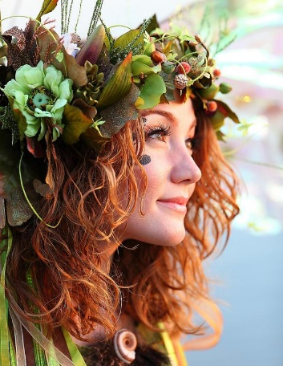
20. Demonstrate appropriation of the following image into a new work of art on the right.

