ELEMENTS AND PRINCIPLES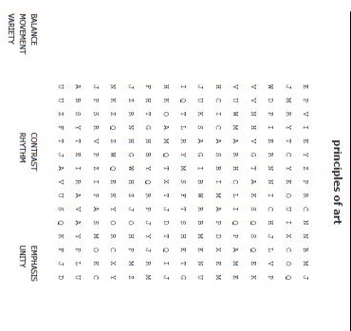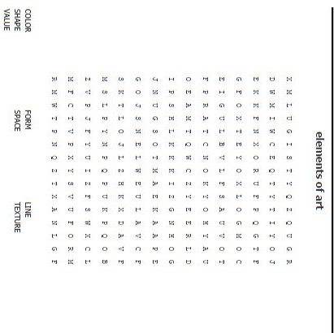
Mnemonic
Device
Mnemonic
Device
SHORT CRITICISM, list in 3 bullet points
Syncretism

Interpret

Judge

Describe

Analyze

Title:______________
Artist/Culture____________

COMPARE AND CONTRAST, Choose two artworks how are the similar, how are they different
Title:______________
Artist/Culture____________
compare
Title:______________
Artist/Culture____________

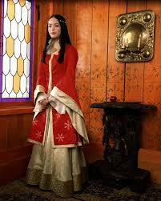
DRAWING IN PROPORTION
PRACTICING VALUE shade the sphere

